
FOOD AND BEVERAGE MANUAL
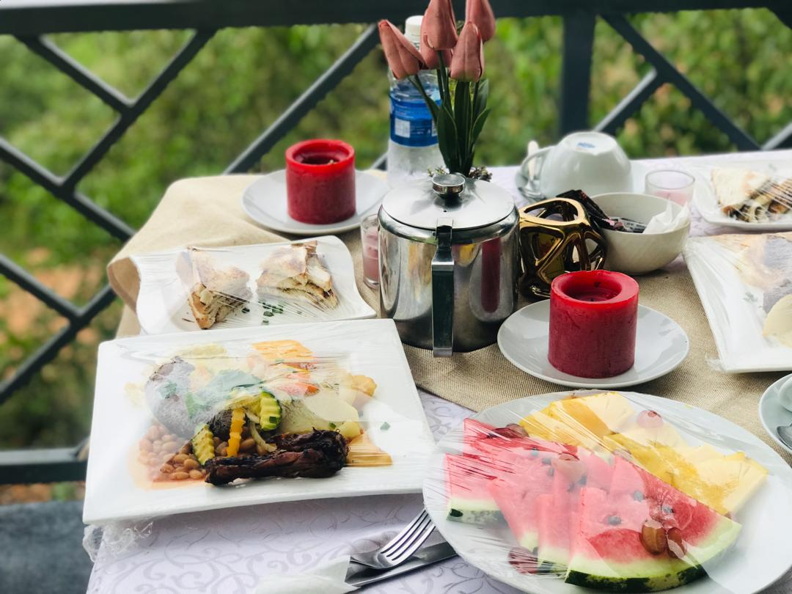
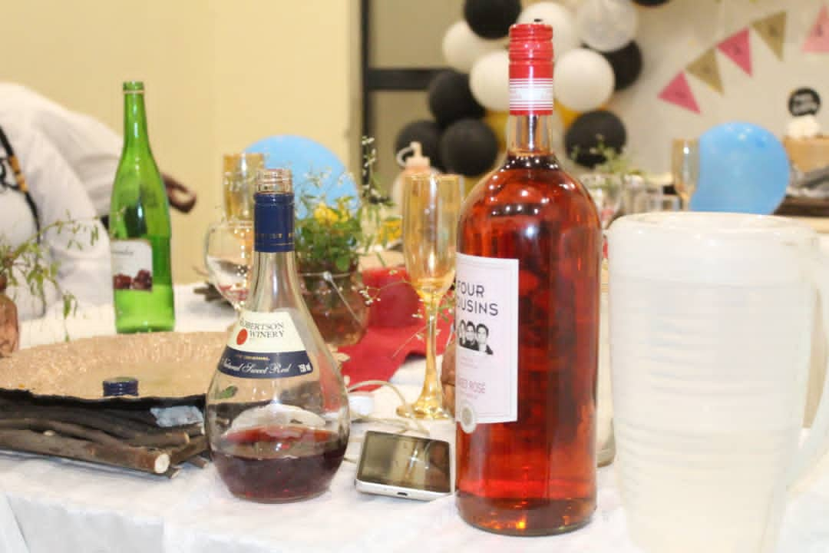
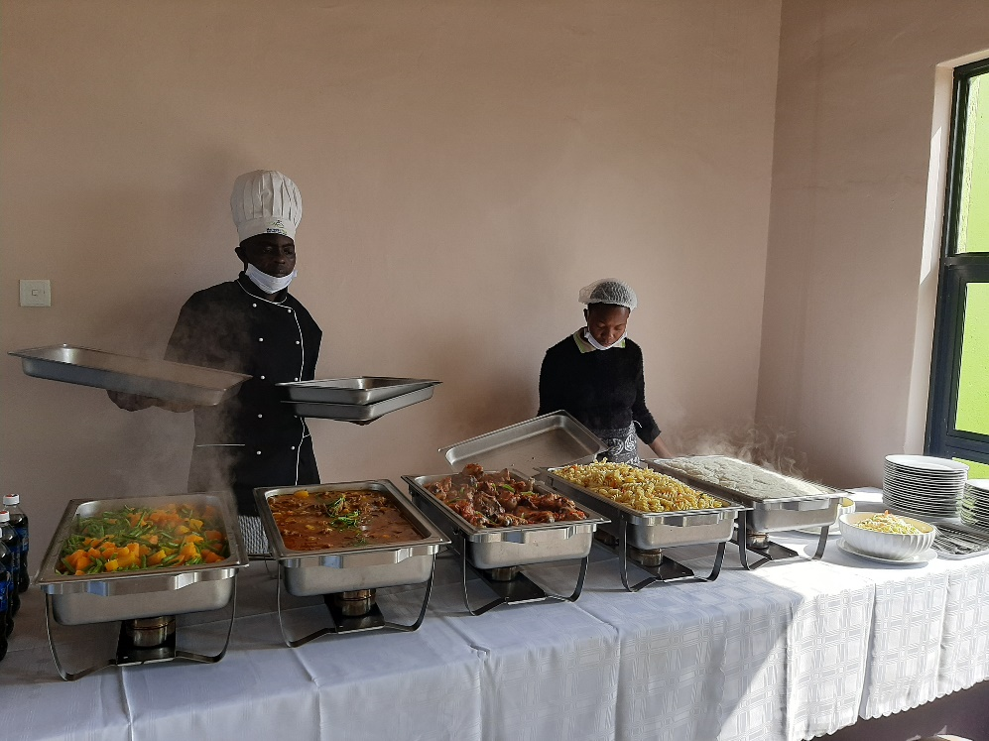
Table of Contents
OVERVIEW 4
1.0 SECTION A - STAFF ETIQUETTE 5
1.1 STAFF RULES AND REGULATION 5
1.2 FOOD AND BEVERAGE ETIQUETTE 6
1.2.1 Kitchen Staff 6
1.2.2 Restaurant Staff 7
1.3 GROOMING & HYGIENE OF STAFF 8
1.4 INTERPERSONAL SKILLS 9
1.5 PERSONAL SKILLS AND TRAITS 9
1.6 GENERAL ROLE, RESPONSIBILITIES OF FOOD AND BEVERAGE 10
1.6.1 Kitchen Staff : Chef 11
1.6.2 Kitchen Staff : Kitchen Porter / Steward 13
1.6.3 Restaurant : Waiter 13
1.6.4 Restaurant Staff : Bartenders 15
2.0 SECTION B - FOOD AND BEVERAGE PROCEDURES - GENERAL 17
2.1 COMMENCEMENT OF THE SHIFT PROCEDURE 17
2.2 DURING SERVICE SHIFT PROCEDURE 17
2.3 AFTER SERVICE SHIFT PROCEDURE 17
2.4 HANDLING GUEST COMPLAINTS PROCEDURE 18
3.0 SECTION C - FOOD AND BEVERAGE PROCEDURES - KITCHEN 20
3.1 FUNCTIONS OF A KITCHEN 20
3.2 KITCHEN OPENING PROCEDURE 20
3.3 KITCHEN CLOSING PROCEDURE 21
3.4 KITCHEN EQUIPMENT MAINTENANCE PROCEDURE 22
3.5 KITCHEN EQUIPMENT CLEANING AND SANITISING PROCEDURE 23
3.6 GARBAGE AREA CLEANING AND GARBAGE DISPOSAL PROCEDURE 24
3.7 KITCHEN PEST CONTROL PROCEDURE 25
4.0 SECTION D - FOOD AND BEVERAGE PROCEDURES – RESTAURANT SERVICE 28
4.1 FUNCTION OF A RESTAURANT 28
4.2 GREETING AND SEATING PROCEDURE 29
4.3 MENU PRESENTATION 29
4.4 ORDER TAKING SERVICE PROCEDURE 29
4.5 POINT OF SALE KEY IN PROCEDURE 30
4.6 ORDER DELIVERY SERVICE 30
4.7 HANDLING BILLS AND FINAL SETTLEMENT 30
4.8 GUEST DEPARTURE AND FOND FAREWELL: 30
5.0 FOOD AND BEVERAGE PROCEDURES – BAR SECTION 31
5.1 FUNCTION OF A BAR SECTION 31
5.2 WINE AND BEVERAGE ORDER TAKING 31
6.0 SECTION F – FOOD AND BEVERAGE SETTING UP & PROCEDURES -BANQUETING SECTION 33
6.1 FUNCTION OF BANQUETING SECTION 33
6.2 SETTING UP BANQUETING 33
6.3 TYPES OF BANQUETING STYLE 34
6.4 SERVICE SEQUENCE BRIEFING PROCEDURE 38
6.5 REQUIREMENTS FOR BANQUET SETUP PROCEDURE 39
6.6 CHECKING BANQUET BUFFET BEFORE SERVICE PROCEDURE 39
6.6.3 Check the bar counter 40
6.6.4 Other points to take into consideration: 40
6.7 PRESERVING FOOD DURING BANQUET PROCEDURE 41
6.8 BILL PREPARATION AND SETTLEMENT PROCEDURE 42
7.0 SECTION G – FOOD AND BEVERAGE CO-ORDINATION WITH OTHER DEPARTMENTS 43
7.1 FOOD AND BEVERAGE CO-ORDINATION WITH FRONT-OFFICE 43
7.2 FOOD AND BEVERAGE CO-ORDINATION WITH HOUSEKEEPING 44
7.3 FOOD AND BEVERAGE CO-ORDINATION WITH HUMAN RESOURCE 44
7.4 FOOD AND BEVERAGE CO-ORDINATION WITH PURCHASE & STORES 44
7.5 FOOD AND BEVERAGE CO-ORDINATION WITH SECURITY 45
7.6 FOOD AND BEVERAGE CO-ORDINATION WITH MAINTENANCE 45
6.7 FOOD AND BEVERAGE CO-ORDINATION WITH SALES AND MARKETING 46
6.8 FOOD AND BEVERAGE CO-ORDINATION WITH FINANCE DEPARTMENT 46
ANNEXES 47

OVERVIEW
The campsite has the Food and Beverage Department. The food production is a section that consists of the main kitchen (hot and cold) section and the restaurant . The food production section comprises of kitchen, banqueting services, soup section, pantry section, pastry section, baking section, confectionary section and vegetable section.
The Restaurant section comprises of waiters and waitress and the head waiter/supervisor.
There is also the bar service that consists of the bar tender who is responsible for selling beverages(non alcoholic and alcoholic)
Food production is the section which involves the preparation of food in which raw materials are cooked, combined and transformed to make a dish. A chef is involved from purchasing to deciding the menu, supervising the kitchen, maintaining the quality of food, sanitation standards, and coming up with new dishes.
In the kitchen (food production section) there is an Executive head chef and chefs. The Executive head chef does more than cooking and has to handle many responsibilities like menu planning and menu engineering and special dishes to be added from time to time. He / She is also responsible for creating recipes, indenting and costing also supervises the purchasing, preparation of food, organisation of kitchen, equipment required in the kitchen, recruitment of staff in the kitchen in co-ordination with the Human Resources department, maintaining the cleanliness and inspecting the quality of raw materials to be used in cooking at the same time be aware of safety standards . Being a chef requires great experience and a flair for cooking .

1.0 SECTION A - STAFF ETIQUETTE
Etiquette refers to the generally accepted standards of good behaviour expected of staff in the Food and Beverage Department. Without etiquette, it would be difficult for the campsite to thrive in the competitive hospitality industry, hence treating people well is of paramount importance.

STAFF RULES AND REGULATION
- Arrive On time, inspired and motivated.
- Neatly dress up in the prescribed housekeeping attire and maintain high grooming standards.
- Smile naturally on stage and backstage.
- Be proactive and motivate each other.
- There is no mine, Food and Beverage department everything is ours.
- Even if smoking is not good for you, you are only allowed to smoke in the designated staff area (As per campsite policy)
- After smoking, please consider our guests and colleagues, wash your hands & take a mouthwash or mint.
- Breaks are important but don’t take extensive ones.
- Always communicate your position with your team mates.
- Keep your eyes open, observe and check our environment permanently.
- Report any irregularities.
- It’s your responsibility to keep the campsite clean, maintained and stylish.
- Every guest is treated as a VIP.
- Never say I don’t know or/and it’s not my job, always offer an alternative.
- Chewing doesn’t look good on you.
- Stand up straight, don’t lean on the wall.
- Keep your mobile phone on silent mode and do not speak on your mobile in the guest areas.
- Don’t hide your mistake, instead learn from it.
- Do not disclose guest details e.g profiles, outside the campsite.
- Never say out the guest room number, instead point out the room number displayed on the key card
- All employees shall log in and out of duty every day at the start and finish of work in the log sheet
- All employees should report to the Head Chef /nominee if they are not fit for work

1.2 FOOD AND BEVERAGE ETIQUETTE

1.2.1 Kitchen Staff
Kitchen Staff should fervently follow the following instructions:
- Kitchen staff and Chefs should wear clean uniforms, aprons and hats/head gear when handling food.
- Uniforms and hats must not be worn outside the premises as this might cause the transfer of bacteria as it may cause cross contamination.
- Kitchen staff must always wear the issued closed safety shoes and socks and at any case, no slippers or bare feet are allowed while working in the kitchen.
- Kitchen staff must be showered and shaved daily when reporting to work.
- Chef's hair must be clean and for females, if hair too long to shoulder, it must be tied back off the face and a head gear should be worn
- Nails are to be clean and short to avoid any food contamination.
- Staff must not wear watches or jewellery, except for a plain wedding ring and small earrings.
- Staff must not wear strong perfume or aftershave while working in the kitchen.
- No food and drink consumption in the food preparation areas should be allowed.
- Smoking in the kitchen or preparation area is strictly prohibited.
- Always wash hands with soap and water and dry with a paper towel.
- Avoid touching food with your bare hands when preparing or serving it.
- Always wear plastic gloves or use clean serving utensils when handling foods.
- Do not lick your fingers while handling or tasting food use a spoon instead.
- Do not blow your nose, cough or sneeze over food.
- If any kitchen staff is suffering from vomiting, diarrhoea or other stomach upsets, skin complaints or cuts inform the executive chef immediately.
- Cuts and abrasions must be covered by an Elastoplast
- Any raw food like chicken, meat, pork etc must not come into contact with cooked / ready to eat food.
- Chefs should never use raw eggs in cooked preparations.
- Never use the same equipment or working surfaces for raw and cooked ready to eat foods without thoroughly cleaning and disinfecting them first.
- Use different cutting boards according to their colour code; Green Cutting Board = Vegetables Only, Red Cutting Board = Meat Only, Yellow Cutting Board = Chicken Only, White Cutting Board = Fish Only.
- Always put food into appropriate clean containers with lids.
- Never place or store any food containers on the floor.
- Wash thoroughly all fruits and vegetables before using them.
- Never mix old food with new.
- Reheat cooked food preparations in small portions.
- Hot food must be kept hot during display or the holding area.
- Cooked food preparations must be chilled rapidly under cold running water or by spreading on a clean tray to avoid contamination
- Label raw and cooked food preparations before putting them into the fridge or freezer.
- Never freeze defrosted food again as it might cause contamination and bacteria buildup.
- Regularly monitor the temperature of fridges at least once a day.
- Always use the FIFO [First in - First out] method in fridges, freezers and storerooms.
- Ensure proper labelling procedure are followed to adhere to the FIFO method.
- Always handle cleaning chemicals with care and store all chemicals away from food.
- Remove garbage frequently but in any case after the night shift.
- The kitchen stewarding area should be kept clean and tidy at all times.
- Treat every client as a VIP guest
- Be aware of any special promotions going on at the campsite
- Kitchen, Food and Beverage staff should possess a thorough / good knowledge of all different menus and their rates
- Food and Beverage staff should conduct themselves with a friendly, cooperative attitude.

1.2.2 Restaurant Staff
Restaurant Staff should fervently follow the following instructions:
- Restaurant staff must be showered and shaved daily when reporting to work.
- Hair must be clean and for females, if hair too long to shoulder, it must be tied back off the face.
- Nails are to be clean and short to avoid any food contamination.
- Staff must not wear watches or jewellery, except for a plain wedding ring and small earrings.
- Please stand up.
- Keep your hands to yourself avoid touching the customer
- Refrain from chewing gum and smoking during working hours.
- Don’t make direct contact with the door knob after washing your hands. Use a paper towel to touch or grab the door handle to avoid transmission of germs.
- Pay attention to where you place your fingers. Make sure your fingers do not touch the rim of the glass, or leave a thumb print on the dinner plate you are serving the customer.
- Refrain from smelling a drink if you arrive at the table and can’t remember which similar looking dark liquid belongs to what customer.
- If you’re sick, please go home report to your supervisor .
- Always bring back the change. .
- Treat every client as a VIP guest
- Be aware of any special promotions going on at the campsite
- Kitchen, Food and Beverage staff should possess a thorough / good knowledge of all different menus and their rates
- Food and Beverage staff should conduct themselves with a friendly, cooperative attitude.

1.3 GROOMING & HYGIENE OF STAFF
- All Kitchen, Food and Beverage staff have to present themselves in a neat and tidy manner putting on a complete Kitchen, Food and Beverage regalia
- All employees should wear the campsite uniform on duty.
- Brush your teeth regularly
- Cover your head with a headgear always
- Do not chew gum, tobacco especially in the food production area
- Wash hands regularly
- Gargle after smoking and have a breath freshener.
1.3.1 All uniforms should be:
- Clean at the start of each day / throughout the day
- Worn in the correct manner
- Shoes worn should be suitable for the role
- A staff member must wear their name tag at all times

1.3.2 Hair
- Short hair should be kept short and neatly cut for men and women
- Long hair for ladies should be kept tight or pulled back
- Ensure that the natural hair colour is maintained
- Men to have well-trimmed facial hair or to be clean shaven.
- Always wear a hair net or cap in any food production area that completely covers all hair.
1.3.3 Nails
- Should be kept short and well-trimmed
- No bright nail polish
- Cleaned on a regular basis.
- No artificial nails

1.3.4 Jewellery
- One dress ring or wedding ring
- Suitable watches
- Minimise jewellery such as bracelets, earrings, nose rings or necklaces.
- Avoid wearing jewellery in the food production area.
- Only a plain wedding ring or wedding band is permitted in the Kitchen.
- No necklaces, bracelets, or dangling jewellery are permitted.
1.3.6 Make up
- Ensure that you do not wear excessive make up or have any visible tattoos.

    - Odour
- Do not wear disproportionate perfumes
- Staff should use deodorant on a regular basis.

    - Personal hygiene
- Bathe or shower before work
- Teeth must be brushed regularly
- Hands and face must be washed and kept clean
- Mobile phones to be on silent

    - Apron
- Always wear your apron on site, as appropriate.
- Do not wear the apron to and from work.
- Always remember to take off the apron before using the restroom.
- Change apron if it becomes soiled or stained.

1.4 INTERPERSONAL SKILLS
For serving the guest and working for cleanliness, the Food and Beverage staff must:
- Possess right attitude.
- Have good listening skills to avoid any miscommunication
- Be a good team player.

1.5 PERSONAL SKILLS AND TRAITS
- The Food and Beverage staff must:
- Be able to retain and pursue the demand of the guest until it is fulfilled.
- Be sincere and physically fit
- Respect each campsite guest they are dealing with. They must conduct themselves confidently and courteously.
- Have high integrity.

1.6 GENERAL ROLE, RESPONSIBILITIES OF FOOD AND BEVERAGE
Food and Beverage Department should:-
- Be able to prepare all Food and beverage mise-en-place duties prior to service.
- Able to provide a warm welcome and fond farewell to the guests.
- Greet guests according to the standards to ensure superior service.
- Anticipate guest needs, ascertain satisfaction, and respond urgently and appropriately to guest concerns and requests.
- Possess good knowledge of a different kinds of dishes
- Good knowledge in maintaining all type of cutlery used in the restaurant for food and beverage service.
- Set up the restaurant according to the table plan, cover layout and standards defined by the hotel's management.
- Make sure all assigned duties prior to service are completed.
- Attend service briefings prior to each meal period.
- Know the restaurant menu and Specials of the day.
- Greet and seat guests.
- Offer Menu and beverage List and attend to napkins/serviettes.
- Take Food and Beverage orders.
- Serve Food and Beverage orders.
- Check and clear Waiter’s station during and after service.
- If required assist in bringing food from kitchen to the guest ensuring accuracy and timeliness.
- Handle all guest complaints in a professional manner.
- Clear soiled cutlery and any other operating equipment to designated wash-up/storage area.
- Able to generate the final bill and offer to guest settlement.
- To clear and re-set tables according to function sheet
- To clean all soiled linen to the designated area.
- Report any theft or damages to the head waiter of the day
- Report to the supervisor before completion of the shift.
- Help other areas of the restaurant such as completing financial transactions.
- Compile your dockets and reconcile with the cashier
- Handover the money to the cashier
- Close the shift after clearing all the tables and washing and cleaning all the service equipment.
- Able to report for duty punctually, wearing a correct and clean uniform and name badge at all times.
- Able to have a complete understanding of the Restaurant’s operating policies and procedures.
- Must participate in staff training and briefings.
- Able to maintain a good teamwork relationship with colleagues.
- Able to maintain a high standard of personal appearance and hygiene at all times.
- Assist in clearing, cleaning and set-up of tables, chairs, linens, china, glass and silver for service in an unobtrusive manner.
- Assist in stocking linens, china, glass, silver, and food items for service.
- Assist in preparation of smaller items such as toast, soup, or beverages.
- Able to carry out other reasonable duties and responsibilities as assigned.

1.6.1 Kitchen Staff : Chef
Duties and Responsibilities:
- Responsible for the consistent preparation of innovative and creative cuisine of the highest quality, presentation and flavour for the dining rooms, banqueting (functions whereby a group of people sit together and have the same meal) and other food facilities, resulting in outstanding guests satisfaction.
- Responsible for the smooth running of the kitchen and manage areas of profit, stock, wastage control, hygiene practices and training within the kitchen.
- Trains, develops and motivates other chefs and culinary staff to meet and exceed established food preparation standards on a consistent basis.
- Teaches preparation according to well defined list of ingredients and set of instructions for the preparation of a dish and follows up and discusses ways of constantly improving the dishes at the campsite.
- Display exceptional leadership by providing a positive work environment, counselling employees as appropriate and demonstrating a dedicated and professional approach to management.
- Should be able to provide direction for all day-to-day operations in the kitchen.
- Understand employee positions well enough to perform duties in employees' absence or determine appropriate replacement to fill gaps.
- Provides guidance and direction to subordinates, including setting performance standards and monitoring performance.
- Utilizes interpersonal and communication skills to lead, influence, and kitchen staff.
- He/She should advocate sound financial/business decision making, demonstrates honesty, integrity and also leads by example.
- Provides and supports service behaviours that are above and beyond for customer satisfaction and guest cancellation of services.
- Improves service by communicating and assisting other chefs to understand guest needs, providing guidance, feedback, and individual coaching when needed.
- Delegates as appropriate to develop supervisors and subordinates to accept responsibility and meet clearly defined goals and objectives.
- Reviews staffing levels to ensure that guest service, operational needs and financial objectives are met.
- Actively involves in menu development and maintaining updated and accurate costing of all dishes prepared and sold in the Food and Beverage operation.
- Determines how food should be presented, and create decorative food displays in platting.
- Recognizes superior quality products, presentations and flavour.
- Ensures compliance with food handling and sanitation standards.
- Follows proper handling and right temperature of all food products.
- Ensures all equipment in the kitchen is properly maintained and in working order in accordance with local Health department and campsite standards.
- Reviews guests feedback forms and comment cards for guest satisfaction results and other data to identify areas of improvement.
- Coordinates with the purchasing department for the requisition of needed goods and services.
- Ensure all products are prepared in a consistent manner and meet departmental appearance/quality standards.
- Ensure proper grooming and hygiene standards for all kitchen staffs.
- Ensures all kitchen employees maintain required food handling and sanitation certifications.
- Ensure proper purchasing, receiving and food storage standards in the kitchen.
- Interacts with guests to obtain feedback on food quality, presentation and service levels.
- Actively responds to and handles guest problems and complaints.
- Maintain Quality levels of receiving, storage, production and presentation of food.
- Ensure sufficient staffing levels are scheduled to accommodate business demands.
- Follows and enforces all applicable safety procedures specified for kitchen and food servers.
- Discuss daily food cost(the cost of ingredients used in the preparation of food) reports with key kitchen and F&B team members.
- Review weekly and monthly schedules to meet forecast and budget.
- Attend the daily morning meetings and other administrative sessions.
- Identifies the developmental needs of kitchen staffs and provide coaching, mentoring, and also helping them to improve their knowledge or skills.
- Trains kitchen associates on the fundamentals of good cooking and excellent plate presentations. Also interview and hire new applicants for kitchen.
- Frequently review finished products for quality and presentation before the orders are sent to guest.
- Able to perform additional duties as requested by the campsite management as and when required.
- Issues dockets to food service team
- Ensures disciplinary procedures and documentation are completed according to the campsite operational Standard and Management Policy.
- Must have an eye for detail and creativity to look at things differently
- Ensures flow of service right straight from food production to service delivery

1.6.2 Kitchen Staff : Kitchen Porter / Steward
Duties And Responsibilities:
- Ensure the kitchen is clean, well maintained and organised at all times.
- Ensure floors are dry and clean at all times.
- Maintain a hygienic working environment in accordance with hygiene regulations and campsite standards.
- Adhere to all sanitation guidelines.
- Assist the Cooks and Servers as and when necessary.
- Collects and removes trash from all areas of the operation following established procedures.
- Dispose of waste as per the campsite’s standards and Adhere to recycling guidelines.
- Ensure waste bin area is kept clean and tidy.
- Carry out general cleaning as directed to include sweeping, mopping up, washing up, emptying of rubbish bins and boxes ensuring placement in the correct containers
- Cleans and sanitizes pots, pans, utensils, and other minor equipment routinely used in the kitchen following established procedures.
- Cleans and maintains floors and walls in the kitchen and sink area by following standard procedures.
- Cleans and sanitizes dishes and related service ware following established procedures.
- Cleans large equipment (gas stoves and fridge’s) as assigned, following the procedures.
- Ensure all equipment is clean and in good working order.
- Check all chemical levels and chemical inventory.
- Wash, wipe, sort, stack and store all cleaned items in an organised and safe manner.
- If any breakages or chipped items found then remove them from circulation and update the breakage and inventory register.
- Clean, sanitise and close workstations.
- Uses and maintains all equipment's according to manufacturer and department guidelines.
- Report any maintenance or hazard issues to the maintenance department
- Assist in clearing the gazebo tables and the dining tables
- Always maintain a clean and safe work environment.
- Perform other cleaning duties of the campsite as assigned.

1.6.3 Restaurant : Waiter
Duties and Responsibilities:
- Greets guests Greet guests according to the standards to ensure superior service and presents them with the menu.
- Informs guests about the special items for the day and menu changes if any.
- Suggest food and beverages to the guest and also try to upsell.
- Assist with stocking and maintain the restaurant par stock levels and side station. Able to prepare all Food and beverage mise-en-place duties prior to service.
- Able to provide a warm welcome and fond farewell to the guests.
- Anticipate guest needs, ascertain satisfaction, and respond urgently and appropriately to guest concerns and requests.
- Possess good knowledge of a different kind of serviceware.
- Good knowledge in maintaining all type of food service equipment used in the restaurant for food and beverage service.
- Set up the restaurant according to the table plan, cover layout and standards defined by the hotel's management.
- Make sure all assigned duties prior to service are completed.
- Attend service briefings prior to each meal period.
- Know the restaurant menu and Specials of the day.
- Greet and seat guests.
- Offer Menu and Wine List and attend to napkins.
- Take Food and Beverage orders.
- Serve Food and Beverage orders.
- Check and clear Waiter’s station during and after service.
- If required assist in bringing food from kitchen to the guest ensuring accuracy and timeliness.
- Handle all guest complaints in a professional manner.
- Clear soiled equipment and any other operating equipment to designated wash-up/storage area.
- Able to generate the final bill from the POS system and offer to guest settlement.
- To clear and re-set tables according to instructions.
- To clean all soiled linen to the designated area.
- Report any theft or damages to Manager/ Assistant Manager.
- Report to Restaurant Manager/ Assistant Manager before completion of the shift.
- Able to report for duty punctually, wearing a correct and clean uniform and name badge at all times.
- Able to have a complete understanding of the Restaurant’s operating policies and procedures.
- Must participate in staff training and briefings.
- Able to maintain a good teamwork relationship with colleagues.
- Able to maintain a high standard of personal appearance and hygiene at all times.
- Assist in clearing, cleaning and set-up of tables, chairs, linens, china, glass and silver for service in an unobtrusive manner.
- Assist in stocking linens, china, glass, silver, and food items for service.
- Assist in preparation of smaller items such as toast, soup, or beverages.
- Able to carry out other reasonable duties and responsibilities as assigned

1.6.4 Restaurant Staff : Bartenders
Duties and Responsibilities:
- Prepare and serve drinks to customers
- Must be able to combine and match ingredients in order to create classic and innovative drinks in accordance with customers’ needs and expectations
- Interact with customers, take orders for drinks and snacks.
- Plan and present bar menu.
- Serve snacks and drinks to the customer.
- Check identification of the guest to make sure they meet age requirements for purchase of alcohol.
- Mix ingredients to prepare cocktails and other drinks.
- Mix drinks, cocktails and other bar beverages as ordered and in compliance with campsite standard drink recipes.
- Prepare alcohol or non-alcohol beverages.
- Serves Wine and Beer to guests.
- Arrange bottles and glasses to make attractive displays.
- Assess customers’ needs and preferences and make recommendations
- Ability to Sell or influence others for up selling and suggestive selling.
- Provide recommendations and suggestions to guest for choosing Drinks and Snacks.
- Serve customers in a friendly and helpful manner.
- Keep the bar counter and work area neat and clean at all times.
- Provide guidance to guests at the campsite activities, dining options and general resort and Regional information.
- Determine when a customer has had too much alcohol and if required refusing any further serving on a polite way.
- Demonstrate a thorough knowledge of food and beverage products, menus and Promotions
- Clean up after customers and clean work area.
- Clear ashtrays as and when required.
- Wash glassware and utensils after each use.
- Maintain a clean working area by sweeping, vacuuming, dusting, cleaning of glass doors and windows, etc. if required.
- Perform physical activities such as lifting and stooping.
- Maintain liquor inventory and consumption.
- Collect payment for drinks served and balance all receipts and dockets.
- Handle an assigned house bank and follow all cash handling procedures as per the campsite standard.
- Prepare inventory or purchase requisitions as needed to replenish supplies.
- Ensure that the assigned bar area is fully equipped with tools and products needed for Mixing beverages and serving guests.

2.0 SECTION B - FOOD AND BEVERAGE PROCEDURES - GENERAL

The Food and Beverage department is responsible in the following areas:
- Kitchen(Food production)
- Food Service / Restaurant
- Bar

2.1 COMMENCEMENT OF THE SHIFT PROCEDURE
- Open windows (attend to ventilation)
- Sanitise all surfaces
- Check menu of the day
- Check the function sheet from the front office
- Check functionality of equipment
- Prepare misen place

2.2 DURING SERVICE SHIFT PROCEDURE
- Pay attention to clean as you go using 3 bucket system
- Sanitise surfaces

2.3 AFTER SERVICE SHIFT PROCEDURE
- Clean all the surfaces, floors and working surfaces
- Switch off all electrical appliances and gas appliances including the gas tanks
- Empty the bins
- Close all the windows and lock all the doors

2.4 HANDLING GUEST COMPLAINTS PROCEDURE

2.4.1 Understand few common reasons for ‘Why Guest complaints?’:
- Unfriendly staff or lack of a warm greeting.
- Pushy servers.
- Excuses by the servers.
- Lack of courtesy by servers.
- Unhelpful attitudes of servers.
- Overly friendly servers.
- Not giving enough responses to guest requests.
- When the servers are not available to take requests. And guest has to wait for servers to return to the table.
- Food not been delivered on time.
- Unhygienic cutleries and crockery used.
- Unacceptable noise levels.
- Cramped dining area.
- Non responsive attitude of management for complaints etc.
2.4.2 Handling Guest complaints
- Calmly and patiently listen and empathize.
- Any complaint received is to be dealt with by the appropriate Department Head and reported to the Manager.
- It is imperative to ensure prompt, efficient and courteous action to any complaint received.
- Initiate the required service recovery steps immediately.
- The correct approach to the customer is the key to success. The staff shall not be servile but anticipate the guests.
- A careful watch shall be kept on the guests at all times during the meal without being obvious.
- Care shall always be taken when dealing with a difficult customer.
- Never argue with a guest as it only aggravates the situation but refer all complaints to the designated superior.
- All written complaints (online or by letter) must be investigated and answered promptly. They shall be handled by the Food and Beverage Manager and brought to the attention of the Manager .
2.4.3 Record the following information on the log book
- Guest’s name.
- Room number.
- Company name.
- Arrival relevant account details on the guest folio.
- Refer to the guest problem in the related file.
- Contact details of the guest email, mobile number etc.

3.0 SECTION C - FOOD AND BEVERAGE PROCEDURES - KITCHEN

FUNCTIONS OF A KITCHEN
A kitchen is a place for the storage and preparation of food for consumption at the campiste. Kitchen cater to different needs from breakfast, luncheon and dinner to events such as dinners, parties and conferences. The purpose of a kitchen is to produce the right quality of food of the highest standard for the required number of people, on time, by the most effective use of staff, equipment and materials.

KITCHEN OPENING PROCEDURE
3.2.1 The Executive Chef should ensure that kitchen staff arrive on duty at the appointed time.
- All kitchen personnel meet the expected requirements of personal hygiene and wear the correct uniform and safety clothes.
3.2.2 Explain the menu items on a daily basis prior to service to all Kitchen staff.
- All the chefs should be familiar with the preparation for the different dishes.
- All the chefs should be familiar with the presentation and garnish required for each dish.
- Make sure the chefs are familiar with all the equipment, plates needed in preparation.
3.2.3 Allocate the sections to respective chefs prior to service.
- All chefs are briefed prior to each shift and are clear on their duties and responsibilities for service.
- Any special requirements for each shift or section should be highlighted.
3.2.4 Ensure that food production personnel work in a professional and efficient manner at all times.
- Food production personnel are fully competent in the preparation of the required dishes.
- Food production personnel should adhere to all kitchen hygiene and safety procedures at all times.
- The Chefs should make sure that their work area is clean and tidy at all times.
- The Chefs should assemble all appropriate ingredients in advance to ensure efficiency and work productivity.
- All initial preparations are completed efficiently and items are stored correctly until required.
    - Assemble dishes in a timely and appealing manner.
- Crockery is correct, clean, polished and not damaged.
- Crockery is placed in a hot box one hour prior to service.
- Dishes should be prepared in accordance with the hotel's standard recipes.
- All orders are dictated to by the executive chef or on the kitchen order display system.
- Every dish is checked by the senior chef before leaving the pass for presentation, quality and portion accuracy.
3.2.6 Ensure that the wash-up or stewarding area and equipment are clean and tidy.
- All equipment should be kept in a clean and safe state at all times.
- Dishwashing machines are checked for cleanliness before use and maintained.
- Water is changed at least twice a day and is at the correct temperature at all times.
- Correct quantities of dishwashing detergent to be used and rinse aid are safely used.
- Waste disposal facilities are effectively used.
- Waiting for staff correctly and safely clear, stack and sort crockery, cutlery and glasses.
- All breakages must be recorded and careless breakages by the staff should be noted and reported to management.

KITCHEN CLOSING PROCEDURE
3.3.1 Ensure that all kitchen areas are fully cleaned prior to closing:
- Make sure that the fridges and storage areas are left in a clean, tidy manner.
- Floors are thoroughly cleaned and mopped.
- The kitchen sinks are empty and cleaned and the wash-up area is closed.
- The food preparation and production areas are cleanly maintained at all times.
- All the accumulated rubbish is removed and disposed of correctly.

3.3.2 Clean and store all kitchen utensils and equipment correctly:
- Only the correct clothes and cleaning materials are used for cleaning.
- Chopping boards used at all stations should be cleaned and sterilized.
- Kitchen equipment should be safely and correctly cleaned and stored in the correct place.
- The cleaning clothes should be sent to the laundry for washing and cleaning agents are stored correctly.
3.3.3 Store all food items correctly:
- Make sure that the food items are correctly covered, labelled and placed in the appropriate fridge/storage areas.
- Fridges used in the kitchen area should be working and operating at the correct temperatures.
- The fridges, storage and supplies areas should be properly locked.
3.3.4 Ensure that all appropriate kitchen equipment is switched off:
- All gas equipment is switched off.
- Hot plates and salamanders are turned off.
- Fat fryers are turned off and covered.
- All power points and outlets are disconnected, where necessary.
- Extraction fan must be switched off.
3.3.5 Conduct final checks to ensure all closing duties are completed:
- Designated personnel ensure that all closing duties are completed.
- Any deviations are identified and rectified.
- Heating, lighting and ventilation are attended to as appropriate.
- Final security check of doors and windows is carried out and required alarms are set, as required.
- All appropriate access doors are locked and the keys are deposited at the security desk or time office.

KITCHEN EQUIPMENT MAINTENANCE PROCEDURE
- All Kitchen/Food Production facility and equipment will be maintained, cleaned and sanitized on a regular basis to ensure the safety of the food prepared and served to customers
- Ensure that all hand washing sink areas are supplied with soap dispensers and disposable towels or functioning air dryers at all times.
- Maintain walk-in and deep freezer facilities so that they function properly and are clean.
- See Temperature Record for Freezer, Temperature Record for Freezer/Refrigerators, and Temperature Record for Refrigerator.
- Take temperatures routinely of water used in the kitchen to ensure that hot (minimum 45º Celsius) and cold (20º Celsius) running water is available at all sinks.
- Check to make sure that there is no possibility of back siphonage in the kitchen sinks and drains.
- Check to make sure that all food waste and rubbish are stored in rodent and insect proof containers with tight-fitting lids.
- Make sure that temperatures of all cooling equipment are taken and recorded routinely to ensure proper calibration of thermometers and proper equipment operation.
- Make sure that temperatures of all heating equipment are taken and recorded routinely to ensure proper functioning and thermometer calibration.
- Record temperatures of holding equipment at least daily to ensure proper functioning and calibration.
- Monitor the maintenance of ventilation systems, ensuring that systems are adequate and regularly cleaned according to the recommended schedule.
- Assure all equipment in the kitchen area is well maintained.
- The executive chef should make sure to contract with an equipment repair company to have preventive maintenance done for all equipment, including calibration of cooking equipment.
- The kitchen staff or the engineering team should make sure to log all preventative and repair work maintenance.
- Review temperature logs to ensure that they are being done and to determine problem areas.
- The Executive Chef should follow up on any equipment issues or needs.
- Maintain all facility and equipment documentation .

KITCHEN EQUIPMENT CLEANING AND SANITISING PROCEDURE
- All Kitchen/Food Production facility and equipment will be maintained, cleaned and sanitized on a regular basis to ensure the safety of the food prepared and served to customers
- The Kitchen Staff/Chef's who use such equipment will be responsible for washing and sanitizing removable parts after each use.
- Equipment that handles potentially hazardous or easily contaminated foods is thoroughly cleaned at least every eight hours.
- All equipment used in the kitchen area should be washed, rinsed, and sanitized after each use to ensure the safety of food served to customers.
- Make sure to disassemble removable parts from equipment.
- Use the three-sink method to wash, rinse, and sanitize all parts.
- Verify sanitizer concentration for each meal period and as necessary per policy.
- Wash, rinse, and sanitize all food contact surfaces of the equipment that is stationary.
- Allow all parts of the equipment to air dry.
- Make sure to re-assemble the equipment once dried.

GARBAGE AREA CLEANING AND GARBAGE DISPOSAL PROCEDURE
Garbage area is very vulnerable to bacterial contamination. The stewarding staff should follow the cleaning and disposal standards to prevent widespread bacterial contamination of the garbage area. The stewarding staff should clearly understand how important it is to keep the garbage area clean, hygiene and also to follow proper garbage disposal procedures.
3.6.1 Dry garbage
- Make sure that garbage is not scattered in the disposal process.
- Prevent bacterial contamination.
- Garbage must be wrapped in plastic and tied.
- Dry Garbage must be separated from wet garbage.
3.6.2 Wet garbage
- Garbage must be wrapped in plastic and tied.
- Placed in Garbage bin and covered.
- Garbage must be separated from Dry garbage placed in the room dry waste.
3.6.3 Garbage area cleaning and Maintaining process
- Broom all garbage area.
- Wet the garbage area with water mixed cleaning solution.
- Brush the entire garbage room area.
- Mop and dry the garbage area for finishing touch.
- Mop all area garbage room for.
- Cleaning to be done regularly to avoid dirt and also to prevent the spread of bacteria.
- Must be cleaned every day.
- Must be cleaned two times a day at 19:00hrs and 05:00hrs.
- General cleaning is done every Friday per week.
- Garbage collection should be done every day (dry garbage and wet garbage).
- Cleaning should be done after transporting garbage from the garbage area.

KITCHEN PEST CONTROL PROCEDURE
The purpose of this policy is to ensure that the campsite kitchen premises have abstained from all pests. Also to ensure problem areas can be identified and effective measures can be taken promptly while ensuring that the minimum disturbance is caused to the kitchen operation. All sincere efforts should be made by the kitchen staff and the management to ensure that pests are controlled in the kitchen area. The kitchen staff should follow the pest management standards defined by the campsite using the following steps.
3.7.1 How to deny access to pests in the kitchen area
- Always make sure to use reputable suppliers for all raw material deliveries.
- Physically check all deliveries for any contamination or pests before they enter the restaurant.
- Immediately refuse the shipments that have signs of pest infestation, such as concern marks on the cardboard containers used to supply the raw materials.
- Keep all exterior openings closed tightly.
- Check doors for proper fit as part of the regular cleaning schedule.
- Report any signs of pests to the Housekeeping Executive
- Report any openings, cracks, broken seals, or other opportunities for pest infestation to the maintenance team.

3.7.2 How to deny pests on food, water and identify pest hiding or nesting place in the kitchen area
- Make sure to dispose of garbage as per the standard and correctly on to the designated areas.
- Keep garbage containers clean, in good condition, and tightly covered in all areas, this applies to both indoor and outdoor area.
- Always clean up any spills around garbage containers immediately.
- Wash the containers thoroughly, rinse them and sanitize containers regularly.
- Store recyclables in clean, pest-proof containers away from the building.
- Place food and supplies after delivery as quickly as possible into the appropriate storage area.
- Keep all food and supplies at least 100 to 150 cm. off the floor and a minimum of 50 cm. away from walls.
- Always remember to refrigerate foods such as powdered milk, cocoa, and nuts after opening as these foods attract insects, but most insects become inactive at temperatures below 5º Celsius.
- Place other opened packages of cereals and grains in storage containers with tight-fitting lids.
- The Executive Chef should make sure to implement the FIFO (First In First Out) inventory rotation, so pests do not have time to settle into these products and breed.
- Clean the Food production facility thoroughly and regularly with appropriate cleaning agents and methods.
- The careful cleaning of kitchen and storage area keeps the area neat and clean, and also eliminates or destroys insect eggs, and reduces the number of places pests can safely take shelter.
3.7.3 How to properly use pesticides in the kitchen
- The Pest Control Operator (PCO) should decide if and when pesticides should be used on the campsite.
- Only such certified Pest Control Operators (PCO) who are trained to determine the best pesticide for each pest, and how and where to apply it.
- The PCO is responsible to store and dispose of all pesticides used on the campsite.
3.7.4 Guidelines for storing pesticides in the food production/kitchen area
- Proper guidelines should be used for all over the counter pesticides which are stored in the kitchen.
- Make sure to keep pesticides in their original containers.
- Store pesticides in locked cabinets and away from food-storage and food preparation areas.
- Store aerosol or pressurized spray cans in a cool place.
- Do to expose pressurized aerosol cans to temperatures higher than 40º to 45º Celsius as they can cause them to explode.
- Check local regulations before disposing of pesticides as many of these pesticides are considered hazardous waste.
- Dispose of empty containers according to manufacturers directions and the local authority/regulations.
- Also, it is important to keep a copy of the used pesticides Material Safety Data Sheets (MSDS) on the campsite.
3.7.5 How to monitor the pest control activities by the Executive Chef
- Make sure to supervise and monitor daily cleaning routines.
- Monitor completion of all cleaning tasks daily against the master cleaning schedule.
- Review and change the master schedule every time there is a change in menu, procedures, or equipment.
- Request employee input in the cleaning program during staff meetings.
- Conduct routine and sudden inspections.
- Review infestation and control issues with the Pest Control Operators (PCO), and take the necessary steps to controlling and/or eliminating pests.
- Follow-up on staff’s reporting with Pest Control Operators as and when necessary.
- Monitor the progress of the pest control activities on a daily/weekly basis.

4.0 SECTION D - FOOD AND BEVERAGE PROCEDURES – RESTAURANT SERVICE

4.1 FUNCTION OF A RESTAURANT
The primary function of a restaurant is to provide food and drink to people outside the home. For a memorable meal the quality of the service is something that guests often remember as much as the food and drink served.
That means that restaurant servers must show extensive knowledge of all types of cuisine and dishes, especially the ingredients and cooking style of the dishes on an a la carte menu. They will need to know and understand the methods of preparation and serving, along with the tools used. Good manners, smart appearance, and flawless personal hygiene are equally essential.

4.2 GREETING AND SEATING PROCEDURE
The Restaurant staff should follow the procedures given below for serving the guest in the restaurant
- Guest should be greeted and welcome with recognition, and should be helped with their coats and bags.
- All guest are welcomed at the entrance.
- Guest are greeted warmly.
- Ask guest name to acknowledge them.
- Use guest name at least twice during the conversation.
- Offer choice of seating.
- Table setting are adjusted to the number of guest.

4.3 MENU PRESENTATION PROCEDURE
- All Beverage menu should be clean and in good condition.
- Menus must be presented to guest opened, Present menu in the guest table and open the first page.
- Always point to any recommendation or house favourites.
- Inform the guest that you will take their order when ready.
- Maintain eye contact and approach at the appropriate time.

4.4 ORDER TAKING SERVICE PROCEDURE
- Staff should have a warm smile and polite attitude, Approach guest table within 10 seconds whenever they need to order.
- Always prepare a note pad and a pen.
- Be attentive at the guest table.
- Take orders from women first, then men.
- Continue to take orders clockwise around the table.
- Use standard drink abbreviations.
- Ask if guests would like to order beverages if requested beverage not available offer recommendation.
- Find out guest preferences for service, such as “on the rocks” or straight up” etc.
- Always repeat the guest order.
- Inform guest of the expected service time.
- Estimate the serving time.

4.5 POINT OF SALE KEY IN PROCEDURE
- Double check all the keyed in order before sending to kitchen.
- Barman should serve the drinks with the specific POS ticket.
- Key in order into the POS system accordingly.
- If any wrong order key in, look for the assistant manager or above to void it immediately.
- When barman gives the drinks to the waiter it should be with the POS ticket.

4.6 ORDER DELIVERY SERVICE PROCEDURE
- Waiter reviews the order and put on the tray.
- Quality check by every staff.
- Acknowledge the guest 2 steps before approaching the table.
- Offer to pour beverage.
- Leave the table by saying
“Is there anything I can assist you at the moment?”

4.7 HANDLING BILLS AND FINAL SETTLEMENT PROCEDURE
- Ensure the bill is accurate, Always Double check the bill before presenting it to the guest.
- The bill is presented in a company bill folder and pen, Retire from the table and stay within the vicinity.
- Recover the check and means of payment.
- Thank the guest and process quickly.
- Payment should be done in 4-5 minutes.

4.8 GUEST DEPARTURE AND FOND FAREWELL PROCEDURE
- Thank the guest by name and bid farewell to all members of the party.
- Help customers leave their table.
- When assisting the guest, ensure ladies first.
- Always says:
“Hope to see you again.”
- The table should be reset immediately.

5.0 FOOD AND BEVERAGE PROCEDURES – BAR SECTION

5.1 FUNCTION OF A BAR SECTION
Bar is an important part of the food and beverage department on the campsite. It provides alcoholic and non-alcoholic beverage to the guest.

5.2 WINE AND BEVERAGE ORDER TAKING
5.2.1 Beverage Order Taking:
- After the guest has been seated, approach the guest’s table with the beverage menu.
- Approach the guest from the right side and ask if she/he would like to have a drink or if she/he would like to see the beverage list.
- Recommend any special drinks or cocktails.
- If the guest requests to see the menu, hand the menu to the guest and step back within attentive distance to wait until the guest has made her/his choice.
- Take order from women first, then men and finally from the host.
- Ask the guest for the order, ask politely;
“Excuse me Madam/ Sir, may I take your order?”.
- Verify the legal drinking age of guests who order alcoholic beverages.
- Place a Beverage napkin in front of every guest as you ask for his or her order. This will help you to keep track of who has ordered.
- Leaving a beverage napkin at the table will let other servers know that you have checked with the guests.
- If the beverage napkins have a logo, then place each napkin so the log face the guest.
- When the guest is ready to order, listen carefully and write down all the details. Face guest when taking the order and maintain eye contact
- Repeat the order, to make sure you get the order correct, by saying:
“Madam/Sir, your order is (list name(s) of beverage item)”.
- Enter the order in the POS terminal (or remote device). Where available, and the order will thus be printed in the dispense bar.
- Where no ‘no-line’ system is available, pass one copy of the Order to the kitchen and one to the cashier.
- Consult the order to check which types of food the guest has ordered.
5.2.2 Wine Order taking:
- Present the wine list.
- Approach the guest, or host if applicable, from the right side and present her/him the wine list with your right hand.
- Recommend the appropriate wine. Red wine is more suitable for red meat, e.g., beef or pork dishes and white wine is more suitable for white meat or seafood dishes, e.g., chicken, fish and shellfish.
- Step back at an appropriate distance.
- When the guest has ordered, repeat the order and thank the guest before leaving the table.

6.0 SECTION F – FOOD AND BEVERAGE SETTING UP & PROCEDURES -BANQUETING SECTION

6.1 FUNCTION OF BANQUETING SECTION
Banqueting section is one of the divisions under the Food and Beverage Department which has responsibility to setup, prepare what is needed in the campsite in handling the events and functions. It handles all special food events at the campsite. Banquet menus has a list of food selections which include festive dinners that celebrate special occasions they serve a single type of appetizer and dessert and allow guests to select their choice of main course.

6.2 SETTING UP BANQUETING
When doing a setup in the Banqueting venue certain layouts can involves design and décor for instance birthday parties, weddings and meetings, these have has complex layout and decorations to that should fit the theme as per the guest request. Whilst a simple coffee break can be served in an undecorated themeless room.
Additionally the guests at banquets and catered events must be served quickly, the layout and service stations should be setup to allow for maximum staff efficiency.
6.2.1 The following are factors that should be considered when laying out a room for a function :
- Space available inside the room.
- Number of the guest ie (minimum guaranteed pax and maximum).
- Expected level of activity and interaction required.
- Place required for dinner tables, meeting tables and head tables.
- Details of equipment's required eg projectors, screen, lecterns, Flip chart, board, dance floor, stage etc.

6.3 TYPES OF BANQUETING STYLE
6.3.1 Wedding Style
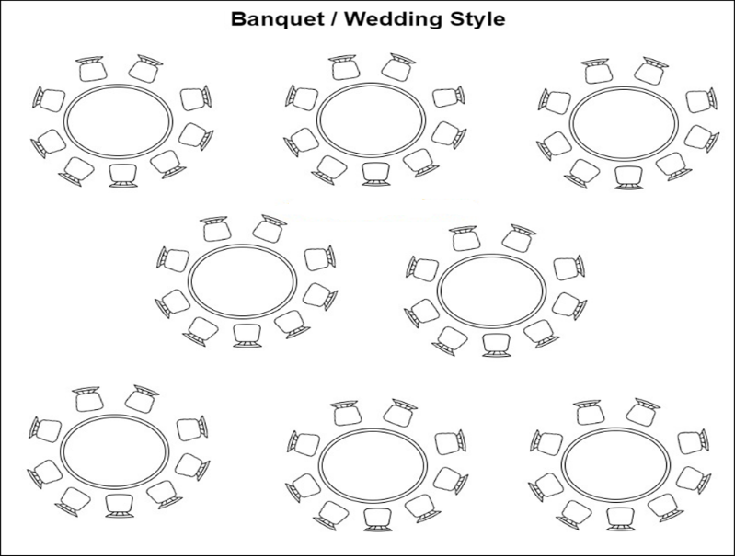

6.3.2 Board Meeting Style
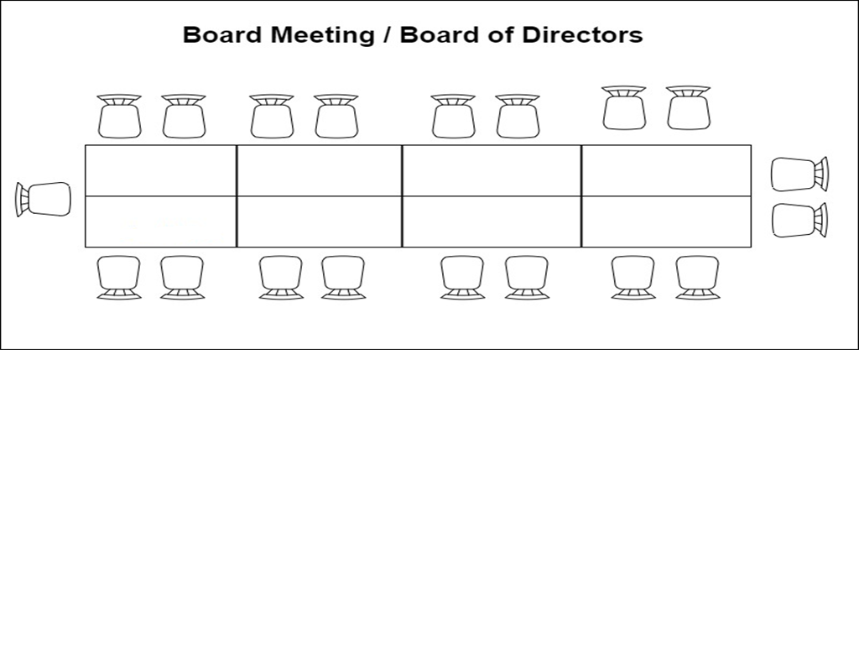

6.3.3 Herringbone or fish bone style

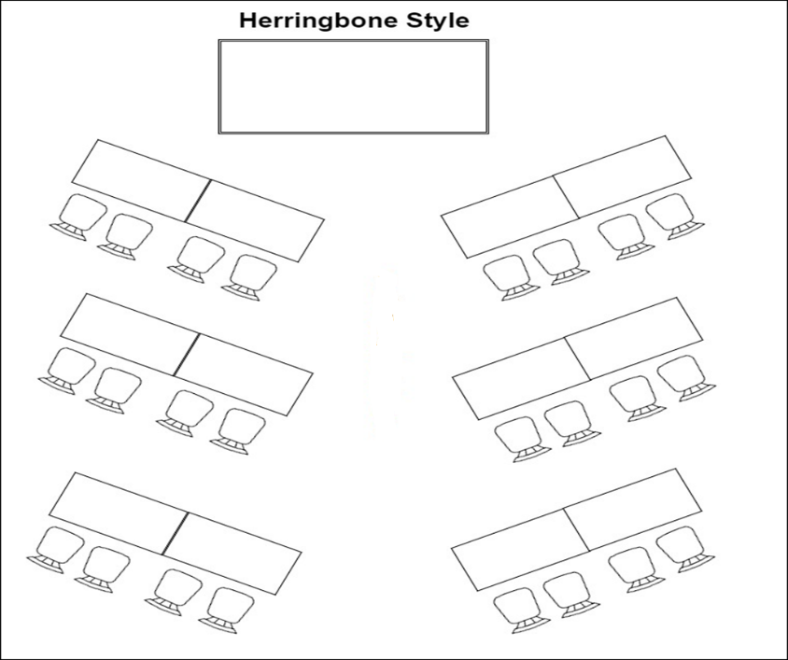

6.3.4 Hollow Square Style
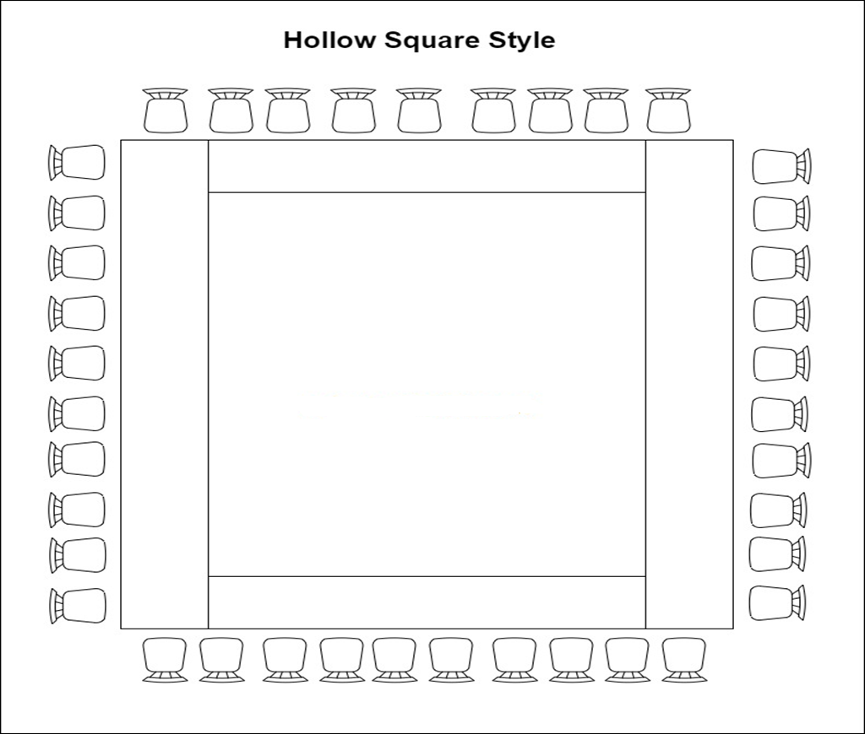

6.3.5 Lecture Room - Training Room Style
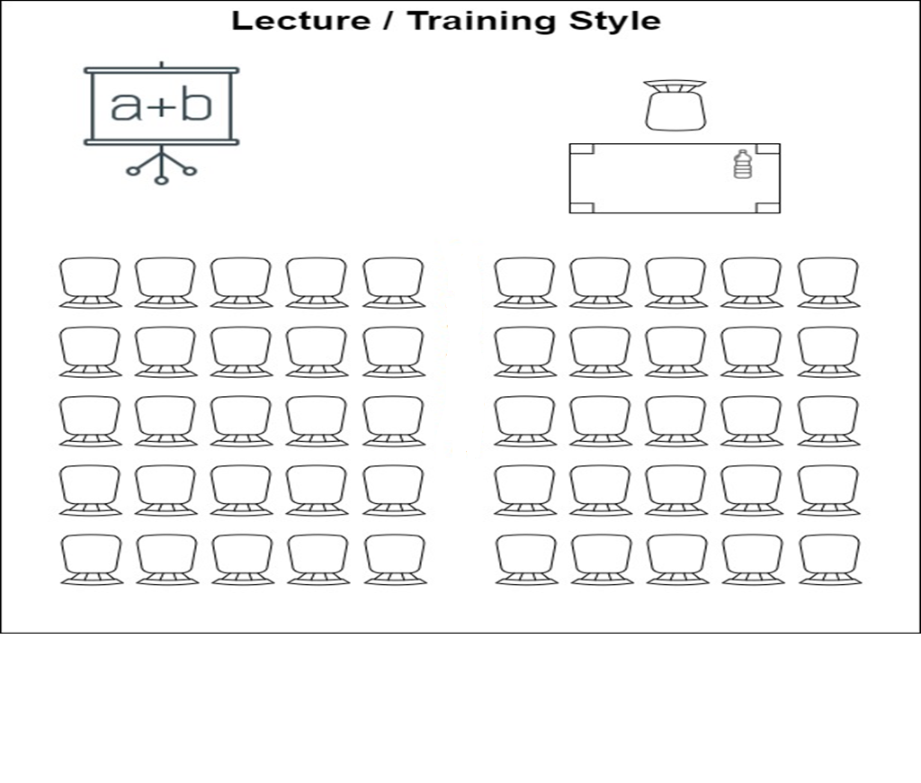

6.3.6 School Room style
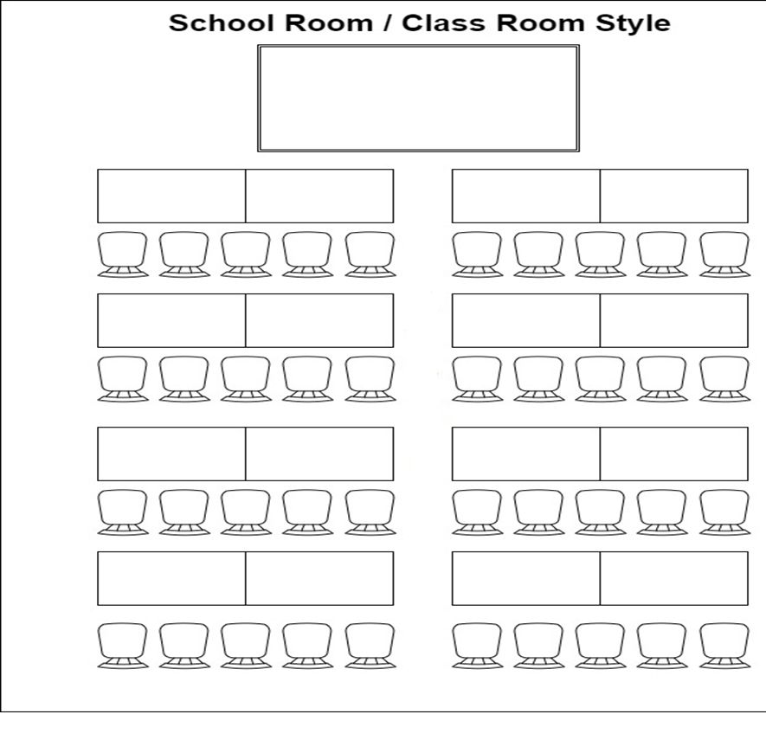

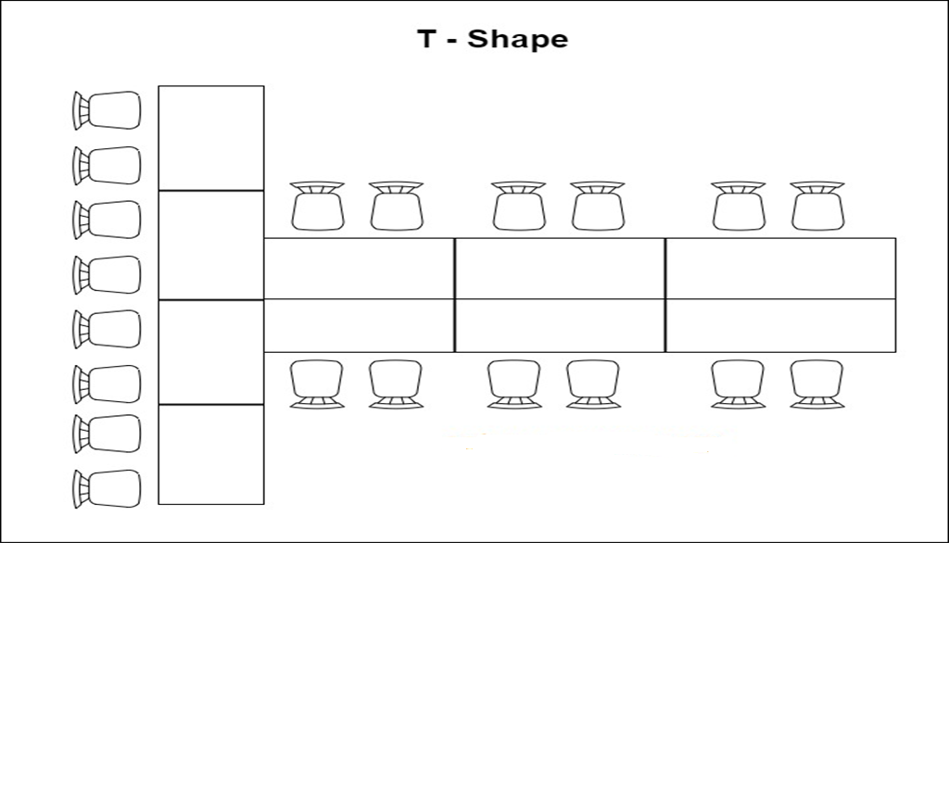
6.3.7 T Shape - Style

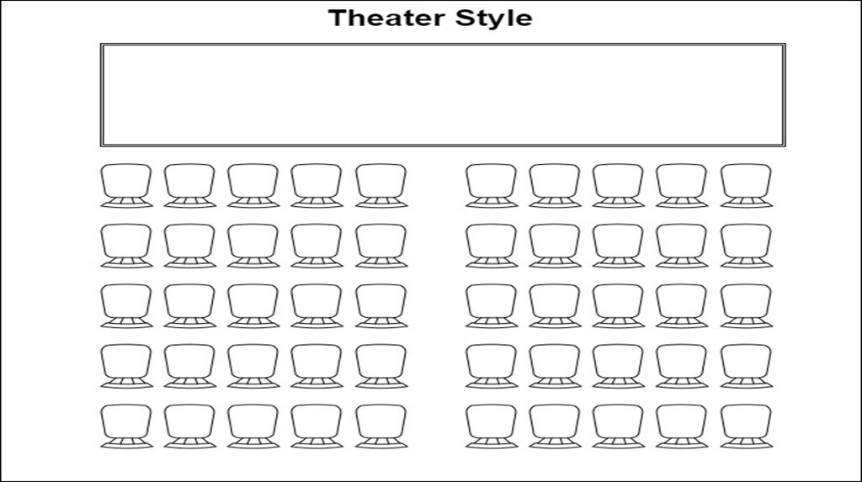
6.3.8 Theater Style

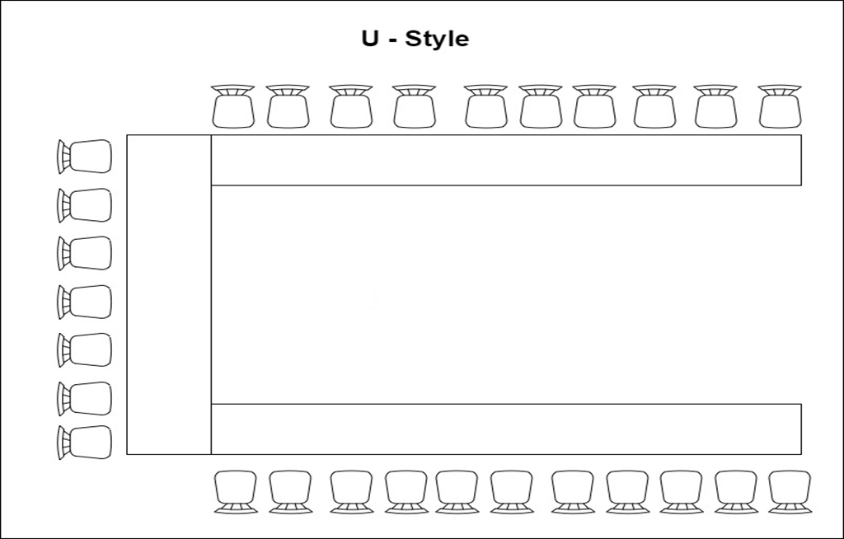
6.3.9 U Style

6.4 SERVICE SEQUENCE BRIEFING PROCEDURE
Before each function, the staff member in charge of the function shall brief all her/his staff on the way the function will take place, allocate tasks accordingly and fix time schedules.
For larger functions, especially when casual staff are involved, a table plan and a job allocation plan must be issued in order to make sure that each staff member knows her/his duties and where to perform them. If needed, a rehearsal shall be organized.
6.4.1 Briefing for banquet functions that will happen on the day
- A good briefing will avoid many service problems during the function.
- The room the function will be held in.
- The number of guests expected.
- Table setup specifications (including the sizes, types and colors of table cloths and table skirts.)
- The menu for the function (including beverages, number of courses and desserts.)
- Review time for guest will arrive, food should be plated, serve each course etc.
- The type of event / function.
- Any Special request made by guest.
- The other subjects covered during the briefings include :
- Food service : menu, way of serving, operating equipment
- Standards of service : mention the do’s and don’ts of banquet service
- VIP guests present and special requests
6.4.2 Service Sequences
- Upon arrival at the campsite the guest co-ordinator/ event organizer shall be welcomed by the staff member who booked the event.
- Staff member introduce the guest to the Banquet Manager in charge of the function,
- Check the function sheet together with the guest co-ordinator to make sure that everything is according to her/his order.
- Clearly signpost the name of the function room where the event will take place as well as the status in order to indicate whether the function is in progress or not.
- Every staff member, especially all casual staff, must be informed about the selected service sequence during the briefing session before the function starts.
- During the banquet meeting and daily banquet briefing, all the steps of the service sequence must be clarified to everybody. The layout of the function room(s), the assigned service area(s), bar counter(s) and/or buffet(s) must be organized before each function.
- All required equipment must be prepared and cleaned to ensure a smooth set-up and service.

6.5 REQUIREMENTS FOR BANQUET SETUP PROCEDURE
The campsite offers different kinds of buffets. Buffets must be set up according to the pre-established layouts, budget and selection of dishes. Any buffet set-up must fulfill the following requirements :
- The buffet shall be ready 15 minutes before the starting time.
- Efficient for both guest service and replenishment.
- Layout and decoration attractive for the guest.
- Adequate lighting, with colors if required.
- Sufficient power points for connecting all the required electrical appliances.
- Sufficient quantity of alternative heating fuel, e.g., gas, and adequate corresponding safety features.
- The buffet service shall be similar to that applied in the restaurant procedure.

6.6 CHECKING BANQUET BUFFET BEFORE SERVICE PROCEDURE
6.6.1 Checking The Buffet Table
- Make a good first impression to the guest, get it right the first time and every single time, as it is very imperative to the guest.
- Make sure enough seats are available to sit the guests in case of sit down buffet.
- Check the distribution of food items.
- Check the presentation of food items.
- Check for any stains or creases on the used tablecloths or napkins.
6.6.2 Checking food items and cutleries.
- Always take personal care and responsibility to ensure the guest’s satisfaction.
- Check the pre situation of food items.
- Check the quantity of all chinaware and cutleries according to the guest's attendance.
- Check chinaware and cutleries for any chips or cracks.
- Check and ensure to have enough supply to delight the guests.
- Make sure all chinaware and cutleries are free of spots.
6.6.3 Check the bar counter
- Enough beverages to be offered for the guests and make sure their availability.
- Enough glassware to be available for service.
- All glassware must be free of spots and no crack.
- Make sure all required garnishes, ice cubes, service tray's, coster etc. are available.
6.6.4 Other points to take into consideration:
- Check the number of buffet tables against the number attending.
- Check the distribution of food items according to the event order to check the items of the food set up.
- Check the presentation of food items.
- Pre-plan the food replacement’s frequency.
- Liaise with chef to check buffet for food quality and presentation standards.
- Check the food setup according to the Event Order or Banquet Event Order.

6.7 PRESERVING FOOD DURING BANQUET PROCEDURE
6.7.1 Keep hot items hot
- If there is less than one quarter of an inch of water in the liners of hot chafing dishes, user a pitcher of water to refill the liners.
- If the chafing dishes are heated by canned, gel type fuel then make sure the cans stay lit, and replace them when they become empty.
- Replace lid on serving dishes when guests are not in the buffet line.
6.7.2 Keep cold items cold
- Use pitchers to add ice to the buffet as needed to keep the containers holding cold items surrounded by ice.
- Remove ice that gets into the food containers and replace any items that become waterlogged.
6.7.3 Refill Food and water
- When a container is less than one-quarter full get a full container from the kitchen.
- Remove the old container and replace it with the full one. Do not combine food from the old and new containers.
- Bring the old container the kitchen and give it to the appropriate person.
- Place enough drinking water glasses filled at all time.
6.7.4 Maintain service ware
- Restock dishes when there are fewer than ten dishes in a stack. Never let a stack get below five dishes.
- Make sure each container has an appropriate serving utensil.
- Return serving utensils to the correct containers.
- Replace utensils that fall on the floor with clean utensils from the kitchen.
- Use a damp, food-safe cleaning cloth to wipe spills on the buffet table.

6.8 BILL PREPARATION AND SETTLEMENT PROCEDURE
- After the function, the bill is made up according to the information on the Banquet Event Order.
- If any changes or extra orders were requested by the guest, they will be added to the total amount (as extra charges).
- The banquet bill will be prepared on the POS (point of sale) terminal system and closed.
- If the Banquet Event Order states that the guest will pay after the function, the Banquet Manager shall accompany the guest to settle the bill.
- Guest might settle the banquet bill by the accepted method of payment as per the campsite policy
- A copy of the F&B POS terminal system bill will be attached for the guest’s reference.
- If the bill is suppose to be send to the company or paid by the guest later ( bill or hold) then the banquet manager should get the signature of the guest on copies of the bill.
- At the end of the day, the Banquet Manager will make a report of all closed checks and will attach the relevant bills
- Drop the banquet bill’s folder at the front desk for onward transmission to the accounts department.

7.0 SECTION G – FOOD AND BEVERAGE CO-ORDINATION WITH OTHER DEPARTMENTS
No work is complete without coordination and documentation. The Food and beverage service department is seen to possess a very dynamic intra and inter departmental interactions in prospect of accomplishing works. This has also made the functioning of the campsite very smooth.
INTER-DEPARTMENTAL

7.1 FOOD AND BEVERAGE CO-ORDINATION WITH FRONT-OFFICE
The co-operation between Food and beverage and front office should be very intimate or close. Front office communicates the daily arrival list to the kitchen and it helps the chefs to forecast their production so that the wastage is minimized. The daily arrival list also contains guest history and the chefs come to know if there was any problem with food or service during the guest’s previous stay. Hence, they could make it up this time by exceeding his/her expectation. The front office circulates VIP lists in the kitchens for any special requests of guests and for the room amenities to be placed in the room. Sometimes welcome drinks are prepared by the kitchen for some VIPs. Front office also assists guests in making their dining choices and helps in marketing the restaurants and outlets.

7.2 FOOD AND BEVERAGE CO-ORDINATION WITH HOUSEKEEPING
The Food and Beverage Department mainly consists of constantly mainly the service staff and the kitchen staff. Both these services requires clean tablecloths, napkins, clean uniforms etc on daily basis. The former because they are in guest contact and the later to maintain the standard of hygiene. Food and Beverage needs to coordinate with Housekeeping to ensure pest control inside the kitchen. Housekeeping is also required in the Food and Beverage Department to get the outlet clean before it opens for the guests.

7.3 FOOD AND BEVERAGE CO-ORDINATION WITH HUMAN RESOURCE
Food and Beverage co-ordinates with the Human Resource department for recruitment of staff, to find the skilled people for the department. Food and Beverage highlight the training and development required by their staff and communicates it to the training department, who then prepares the training calendars and train people accordingly. Appraisals and career developing of the kitchen people is Raised with the Human Resource department. Joining formalities of the new staff, induction, orientation, accommodation facilities etc. are dealt by Human Resources department. The HR also comes up with Personal policy on staff meals, shares staff meal cost with personnel department.

7.4 FOOD AND BEVERAGE CO-ORDINATION WITH PURCHASE & STORES
The purchase and stores department helps the Food and Beverage in purchasing and stocks of various items used in Food and Beverage department. This department procures raw materials at the best possible prices, not compromising on the quality of ingredients. Chefs help the purchase department to create the standard purchase specifications for commodities. Chefs must give sufficient time for the orders to be procured and so maintaining of par stock levels are decided by the chefs and the purchase department depending upon the frequency of withdrawals and availability from the market. Chefs also receive the goods at receiving bay, thereby ensuring that the right quality of ingredients as per the standards specified is purchased.

7.5 FOOD AND BEVERAGE CO-ORDINATION WITH SECURITY
The relation between Food and Beverage Department department and Security is important as the Security Department oversees items taken out and in of the campsite. Items taken out are taken on a ‘gate pass’. This can be returnable or non- returnable. It is made in triplicate and one copy is retained in the book, one goes to finance department and the other one goes to security department. Keys of certain areas are deposited in the security and only authorized personnel can withdraw the same . Sometimes store room needs to be opened in case of emergencies. In such a case, the normal procedure is to inform duty manager who will inform security and together with chef the stores shall be opened in front of security supervisor and duty manager and locked duly after the commodity is withdrawn against a store room requisition.

7.6 FOOD AND BEVERAGE CO-ORDINATION WITH MAINTENANCE
Maintenance department does the preventive and breakdown maintenance of the equipment used in the kitchen. It helps in installation of new equipment and trains the staff in its usage and precautions. Coordinates with chefs to utilize the resources effectively to minimize costs and increase profits. Maintenance schedules are made and followed up by chefs. Fire fighting and safety procedures are laid down by the engineering and followed up by the chef.

6.7 FOOD AND BEVERAGE CO-ORDINATION WITH SALES AND MARKETING
The relation between Food and Beverage Department department and sales marketing is important as the sales and marketing informs the house keeping of the occupancy forecast be it weekly, monthly and yearly. This enables Food and Beverage Department. This department helps the chefs to promote new menus and festivals. Sales department promotes the chefs so as to increase the sales of their product. Sales and Marketing works in close coordination with the kitchen to sell the menus and bring in more business.

6.8 FOOD AND BEVERAGE CO-ORDINATION WITH FINANCE DEPARTMENT
The Finance Department does the costing of the recipe and this helps the management to decide upon the selling price to get the desirable profits and maintain the agreed food cost. Finance helps chefs and the purchase managers to go for regular market surveys and see if any new and better quality products are available. Finance helps chefs to keep a check on their expenses by giving a periodic report mentioning their profits and losses.

ANNEXES
ANNEX 1: | EVENT / FUNCTION ORDER FORM
ANNEX 2: | EVENT / FUNCTION CHECKLIST
ANNEX 3: | BAR CHECKLIST
ANNEX 4: | RESTAURANT CHECK LIST
ANNEX 5: | SERVICE CHECKLIST
ANNEX 6: | EQUIPMENT CHECKLIST
ANNEX 7: | ORDER TAKING
ANNEX 8: | STOCKSHEET/ PRODUCTION SHEET


ANNEX 1 : EVENT /FUNCTION ORDER FORM
Generated Date |  | Created By
Function / organisation Name:
Contact: |  |  | Function Date
Address: |  |  | Telephone:
 |  |  | Email:
Status: | Rev 1 Rev 2 Final |  | Pax:
Room / Venue Booked |  |  | Special diet
Gender/composition |  |  | Age group range
Any preferences

Notes to Departments (
BANQUET OPERATIONS | HOUSE KEEPING
FOOD & BEVERAGES OPERATIONS | KITCHEN
ENGINEERING AND MAINTENANCE | EVENT SETUP
RESERVATIONS | SALES & MARKETING
HUMAN RESOURCES | RESTAURANT
BAR | FRONT OFFICE
PURCHASING | STORES

Menu
APPETIZER:

SOUP :

MAIN COURSE:

DESSERT:

BILLING NOTES:
Full bill to company, signature of the host is required on final bill

DISTRIBUTION TO:

Food and Beverage Manager Banquet
Restaurant Manager Bar
Accounts Chef
Stores House Keeping
Maintenance Engineering Purchasing
HR Front Office

ANNEX 2 - EVENT / FUNCTION (BIRTHDAY, CONFERENCE, BANQUET, etc ) CHECKLIST
Function Name: | Contact:
Date of Function: | Contact Number:
Time: | Venue:

 |  |  |  |  |  | Tick / Comment |  | Date
 | Return Call of enquiry
 | Menu from Chef
 | Proposal and Menu sent to Client
 | Confirmation from the Client
 | Payment Method
Bank Transfer |  |  | Ecocash |  | Cash
 |  | Contract sent to the client
 |  | Signed Contract received
 |  | BEO (Details of events sent out to relevant departments)
 |  | Deco requested
 |  | Staff strength In terms of labour is the kitchen & Restaurant covered
 |  | Entertainment
 |  | Alcohol / Non - Alcohol
 |  | Equipment (proper equipment for the function)
 |  | Menu (Chefs proved)
 |  | Bill of Quantities (Check if all commodities that were purchased have been received)
 |  | Work plan
Additional Information / Notes:

COMPLIED BY:-……………………………………………………..
DATE …………………………………………………………..

ANNEX 3 : BAR CHECKLIST

 | DESCRIPTION | TICK/ COMMENT
 | Bar is free from bad smell and odours.
 | Environment felt secure and comfortable.
 | Channel Music is ON and hid the kitchen noises, but did not impede conversations.
 | Music played is also appropriate to the venue theme or tempo.
 | For live musical performances, the entertainers were dressed and behaved appropriately.
 | Light fixtures are fully illuminated, no burned out bulbs.
 | Floor is not damaged, free of stains and debris
 | Walls and ceilings are free of chips, scuffs or marks.
 | All mirrors are polished and free of smudges.
 | All windows are free of smudges, streaks and spots.
 | Plant and floral decorations are fresh.
 | Tables and chairs are secure, free of wear and unsoiled.
 | Table cloth and linens are not soiled and damaged.
 | Glassware is free of spots and smudges.
 | All Glassware is free of spots and smudges.
 | Glassware is free of chips, cracks, scratches and wear.
 | Beverage menu is current, not soiled and not damaged.
 | All wall frames displays are free of dust and fingerprints.

DATE…………………………………………………………..
TIME…………………………………………………………..
CHECKED BY:-……………………………………………………..


ANNEX 4 : RESTAURANT CLEANLINESS CHECKLIST

DESCRIPTION | TICK/ COMMENT
- Restaurant is free from bad smell and odours.
- Environment felt secure and comfortable.
- Channel Music is ON and hid the kitchen noises, but did not impede conversations.
- Music played is also appropriate to the venue theme or tempo of the restaurant.
- Light fixtures are fully illuminated, no burned out bulbs.
- Floor is not damaged, free of stains and debris
- Walls and ceilings are free of chips, scuffs or marks.
- All mirrors are polished and free of smudges.
- All windows are free of smudges, streaks and spots.
- Plant and floral decorations are fresh.
- Tables and chairs are secure, unsoiled, free of crumbs and debris.
- Table cloth and linens are not soiled and damaged.
- Glassware is free of spots and smudges.
- All Glassware is free of spots and smudges.
- Glassware is free of chips, cracks, scratches and wear.
- Wine and Beverage list is current, not soiled and not damaged.
- Menu is current, not soiled and not damaged.
- All wall frames displays are free of dust and fingerprints.

DATE…………………………………………………………..
TIME…………………………………………………………..
CHECKED BY:-……………………………………………………..


ANNEX 5 : SERVICE CHECKLIST

 | DESCRIPTION | - TICK | COMMENT/CONDITION
 | Bottle opener
 | Butter dishes
 | Chaffing dishes
 | Chaffing fuel(spirit ,cotton wool, lighter)
 | Condiments
 | Tongs
 | Menus
 | Required cutlery as per menu
 | Service plates
 | Serving ladles
 | Serving towels
 | Serving utensils
 | Sugar bowls
 | Teaspoons
 | Tea and coffee cup and saucer
 | Teapots
 | Wine opener
 | Hand washing bucket
 | Paper towel
 | Glasses

DATE……………………..
DONE BY…………………… CHECKED BY………………………


ANNEX 6 : EQUIPMENT CHECKLIST

Description | Condition | Comment
Sink
4plate Gas Stove
2plate Gas Stove
3plate Gas Stove
Chip Fryer
Griller
Microwave
Electric Jug
Upright Fridge
Deep Freezer
Waiters Table
Working Table

DATE……….. ………………………………………………………………………….
CHECKED BY……………………………………………………..


ANNEX 7 : ORDER TAKING

Waiter’s Name ……………………………………………………. Received By ……………………………
Witness ………………………………………… Time…………………. Date …………………………..
Comments …………………………………………………….…………………………………………………………..

 | MOCKTAILS
……………………………………………………………………… | ………………………………………………………………………
……………………………………………………………………… | ………………………………………………………………………
……………………………………………………………………… | ………………………………………………………………………
……………………………………………………………………… | ………………………………………………………………………
……………………………………………………………………… | ………………………………………………………………………
……………………………………………………………………… | ………………………………………………………………………
……………………………………………………………………… | DRINKS
……………………………………………………………………… | ………………………………………………………………………
……………………………………………………………………… | ………………………………………………………………………
……………………………………………………………………… | ………………………………………………………………………
……………………………………………………………………… | ………………………………………………………………………
PLATTERS | ………………………………………………………………………
……………………………………………………………………… | ………………………………………………………………………
……………………………………………………………………… | ………………………………………………………………………
……………………………………………………………………… | EXTRAS
……………………………………………………………………… | ………………………………………………………………………
……………………………………………………………………… | ………………………………………………………………………
……………………………………………………………………… | ………………………………………………………………………


CUSTOMER FOOD DOCKET NO. 2105
DATE …………………………..
TIME ……………………….. TOTAL $

Sit in Room Service Take Away


ANNEX 8 : STOCKSHEET / PRODUCTION SHEET

DATE…………………………………..
CATEGORY |  | CODE

DESCRIPTION | OPENING STOCK | DELIVERIES/ NEW STOCK | BREAKAGES | SALES | CLOSING STOCK CALCULATED | CLOSING STOCK ACTUAL | COST | COMMENT
TOTAL

EMPLOYEE INFORMATION
STOCKTAKE DONE BY: STOREMAN………………………………………………………………… …
CHECKED BY: SUPERVISOR NAME………………………………………………………………………

